Movie recommendation system Group - B32

Kumar Abhijeet, Roll No-12621018023, Reg No-211260130810032 Suraj Kumar, Roll No-12621018052, Reg No-211260130810059
Amar Sonu Nath, Roll No-12622018064, Reg No-221260121000 Arpan Maity, Roll No-12622018066, Reg No-221260121002

ABSTRACT

This project aims to build a movie recommendation system using machine learning. It uses the TMDB 5000 Movies dataset to suggest films to users based on their preferences. The system looks at features like genre, cast, and keywords to make personalized movie suggestions.

The methodology involves preprocessing the dataset, including data cleaning, feature selection, and text vectorization using the Bag-of-Words technique with CountVectorizer. By calculating cosine similarity between movie vectors, the system identifies and recommends movies that are most similar to the input movie. Tools such as Python, Pandas, and Scikit-learn were extensively used for implementation.

Results demonstrate the effectiveness of the model in generating accurate recommendations. While the system performs well with content-based filtering, potential improvements include incorporating user ratings and collaborative filtering to enhance personalization. This project highlights the practical application of machine learning in recommendation systems.

TABLE OF CONTENT
- Introduction…………………………………………………………………..
  - Background of Recommendation Systems
  - Motivation for the Project
  - Objectives and Scope

- Literature Review…………………………………………………………….
  - Overview of Related Work
  - Techniques Used in Existing Recommendation Systems
  - Importance of Movie Recommendation Systems

- Data Description……………………………………………………………..
  - Source of Data (TMDB 5000 Movies Dataset)
  - Description of Dataset (Size, Structure, Key Features)
  - Data Preprocessing Steps

- Methodology………………………………………………………………….
  - Data Preprocessing and Cleaning
    - Removing Unnecessary Columns
    - Handling Missing Values
    - Combining and Transforming Columns
    - Text Preprocessing
  - Feature Selection (Genres, Keywords, Cast, Crew, etc.)
  - Tag Creation and Text Representation
  - Cosine Similarity

- Implementation……………………………………………………………….
  - Tools and Libraries Used (Python, Pandas, Sklearn, etc.)
  - Code Explanation (Key Functions and Algorithms)
  - Creation of Movie Vectors and Similarity Calculation

- Evaluation and Results……………………………………………………….
  - Evaluation Metrics (if applicable)

  - Performance Analysis
  - Sample Recommendations and Results

- Frontend of the Project…………………………………………………
  - Streamlit Interface Setup
  - User Input Handling (Movie Selection)
  - Displaying Recommendations

- Discussion and Analysis……………………………………………………..
  - Strengths and Limitations of the Model
  - Challenges Faced During Implementation
  - Insights Gained from the Project

- Future Work………………………………………………………………………
  - Potential Improvements (e.g., incorporating ratings, using TF-IDF or deep learning)
  - Scalability and Extensions
  - Enhanced User Interface
  - Multi-Modal Recommendations
  - Real-Time Recommendations

- Conclusion………………………………………………………………………….
  - Summary of Findings
  - Key Takeaways

- References…………………………………………………………………………
  - Papers, Articles, Datasets, and Libraries Cited

- Appendices …………...................................................................................
  - Full Code

- Glossary/Abbreviations .......................................................................

Introduction
Recommendation systems are widely used on digital platforms to give users personalized content suggestions. They work by analyzing user preferences and content details. With the huge amount of content available—especially movies—these systems help users find what they like faster. This project aims to build a movie recommendation system using the TMDB 5000 Movies dataset. It uses machine learning methods like the Bag-of-Words model and CountVectorizer to suggest movies. This report explains the goals, methods, and main results of the project.

Background of Recommendation Systems

Recommendation systems help users explore large datasets by offering suggestions based on their interests and behavior. They are used in many fields like online shopping, streaming services, and social media. For movie recommendations, these systems consider things like user ratings, genres, and cast to find movies that match a user's preferences. Common approaches include collaborative filtering, which uses user activity, and content-based filtering, which looks at movie details. With the help of machine learning, these systems have become more accurate and efficient. This project aims to use these techniques to build a working movie recommendation system.

Motivation for the Project
The growing availability of content across digital platforms has made it increasingly difficult for users to find relevant media, particularly in domains like movies. With millions of films available, users often feel overwhelmed by the vast selection, leading to a need

for efficient tools to help in decision-making. Recommendation systems aim to solve this problem by providing personalized suggestions that match individual preferences. The motivation for this project lies in exploring the potential of movie recommendation systems to offer more tailored and efficient suggestions, enhancing user experience. By developing a recommendation system based on machine learning techniques, the project aims to improve movie discovery and help users make more informed choices.

Objectives and Scope of the Project

This project aims to build a movie recommendation system using machine learning. It focuses on giving users personalized movie suggestions based on their likes. Using the TMDB 5000 Movies dataset, the system will analyze features like genres, keywords, cast, and crew. It will also use the Bag-of-Words method to represent text and find similar movies. The goal is to create a simple yet effective recommendation system that can be improved and expanded in the future for real- world use.

Literature Review
The literature review covers the evolution of recommendation systems, focusing on movie recommendations. It discusses various techniques, including collaborative filtering, content-based filtering, and hybrid approaches, each relying on different data types such as user behavior or item features. The review also highlights advanced methods like matrix factorization and deep learning, which improve accuracy and personalization. Additionally, it addresses challenges faced by recommendation systems, such as data sparsity, cold-start problems, and scalability, which continue to shape ongoing research in the field.

Overview of Related Work
Over time, different types of recommendation systems have been developed, mainly content-based and collaborative filtering. Content-based filtering suggests movies by looking at features like genre, cast, and keywords. Collaborative filtering recommends movies based on what similar users have liked. Studies have found that combining these two methods into a hybrid system can give better results. Research also points out the difficulty of scaling these systems and the need to choose the right features when working with large datasets like the TMDB 5000 Movies dataset, which offers detailed movie information.

Techniques Used in Existing Recommendation Systems
Existing recommendation systems commonly use techniques such as collaborative filtering, content-based filtering, and hybrid models. Collaborative filtering relies on user-item interaction data to suggest items based on similarities between users or items. Content-based filtering, on the other hand, recommends items by analyzing the characteristics of the items themselves, such as movie genres, keywords, and cast.
Hybrid models combine both techniques to enhance recommendation accuracy by leveraging the strengths of each approach. Other advanced techniques include matrix factorization and deep learning models, which aim to improve performance by capturing complex patterns and interactions in the data. These methods, however, often require large datasets and substantial computational resources for effective implementation.

Importance of Movie Recommendation Systems
Movie recommendation systems play a crucial role in personalizing user experiences on streaming platforms by helping users discover content relevant to their preferences.
With the vast number of movies available, these systems help in narrowing down

options, improving user engagement, and enhancing customer satisfaction. By analyzing past viewing behavior, user ratings, and movie attributes such as genre and cast, recommendation systems provide tailored suggestions, saving users time in content selection. Furthermore, these systems also benefit content providers by improving retention rates, increasing the time spent on platforms, and driving more viewership to specific titles. As a result, movie recommendation systems have become an essential component of the entertainment industry.

Data Description
This section provides an overview of the dataset used in the project, including its source, structure, and key features. This project uses the TMDB 5000 Movies dataset, a popular choice for building movie recommendation systems. It contains information about 5,000 movies, including details such as movie titles, genres, cast, crew, keywords, and other relevant metadata. The size and structure of the dataset are examined to understand its suitability for building a movie recommendation system.
Additionally, the key features such as genres, keywords, and cast are highlighted as important factors in generating movie recommendations. Data preprocessing steps are also discussed to ensure the dataset is clean and suitable for model training.

Source of Data (TMDB 5000 Movies Dataset)

The TMDB 5000 Movies dataset used in this project comes from The Movie Database (TMDb), a platform that offers detailed information about movies. Available on Kaggle, the dataset includes data on over 5,000 films, such as titles, genres, cast, crew, release dates, and keywords. It was chosen for its rich content and is well-suited for building recommendation systems that consider multiple features. The dataset is detailed enough to support various data analysis and modeling approaches.

The dataset is available on Kaggle at the following URL: https://www.kaggle.com/datasets/tmdb/tmdb-movie-metadata?select=tmdb_5000_
credits.csvhttps://www.kaggle.com/datasets/tmdb/tmdb-movie-metadata?select=t mdb_5000_movies.csv

Description of Dataset
The TMDB 5000 Movies dataset provides metadata for over 5,000 movies, structured into various columns that describe key details of each movie. Below are the main features of the dataset:
- Budget: The production budget of the movie.
- Genres: The categories of the movie, such as Action, Comedy, Drama, etc.
- Homepage: The official webpage link for the movie (if available).
- ID: A unique identifier for each movie.
- Keywords: Relevant terms that describe the themes or subjects of the movie.
- Original Language: The language in which the movie was originally produced.
- Original Title: The original title of the movie.
- Overview: A brief summary or description of the movie's plot.
- Popularity: A numerical representation of the movie's popularity based on social media and public reception.
- Production Companies: Companies responsible for the production of the movie.
- Runtime: The total runtime of the movie in minutes.
- Spoken Languages: Languages spoken in the movie.
- Status: The current status of the movie (e.g., released, upcoming).
- Tagline: A brief tagline associated with the movie.
- Title: The official name of the movie.
- Vote Average: The average rating given to the movie by users.
- Vote Count: The total number of votes the movie has received.
- Movie ID: A unique identifier for each movie entry.
- Cast: The main actors involved in the movie.
- Crew: The key crew members, including directors and producers.
This dataset is comprehensive, offering multiple attributes that are useful for building recommendation systems. It is structured to enable easy processing and analysis, making it a valuable resource for movie recommendation tasks.

Additional Dataset Description

In addition to the TMDB 5000 Credits dataset, another dataset used in this project focuses on the relationships between movies, their cast, and crew. This dataset contains the following key features:
- Movie ID: A unique identifier for each movie, used to link this dataset with the TMDB dataset.
- Title: The official title of the movie.
- Cast: A list of actors and actresses involved in the movie, which can be used to identify similar movies based on the involvement of the same cast members.
- Crew: Key production personnel, such as directors, producers, writers, and other
important contributors to the movie.
The dataset gives useful details about the roles of people involved in making movies. This helps the system recommend films based on users' favorite actors or directors, making suggestions more personalized.

Data Preprocessing Steps
In this project, data preprocessing involved several key steps to prepare the dataset for use in the recommendation system. These steps were essential for ensuring that the data was clean, relevant, and ready for analysis.
Removing Unnecessary Columns: We started by eliminating irrelevant columns from the dataset, such as budget, homepage, id, original_language, original_title, and status. These columns were not directly useful for building the recommendation model and were removed to simplify the dataset.
Handling Missing Values: Missing data in the overview and genres columns was handled by filling missing overview values with an empty string and genres values with the placeholder "Unknown". This ensured that the recommendation system would not fail due to missing values.
Combining and Transforming Columns: The genres, keywords, cast, and crew
columns were combined into a single string for each movie. This allowed us to

represent each movie's features as a single text entry, which was important for applying the Bag-of-Words approach for text vectorization.
Text Preprocessing: For the overview column, we performed tokenization, lowercasing, and removal of stop words, which helped standardize the text and removed any irrelevant words that would not contribute to the similarity calculation between movies.
These preprocessing steps helped structure the data in a way that allowed for meaningful similarity comparisons between movies based on their features, which is a key part of the recommendation system's functionality.

Methodology
This section explains the steps taken to build the movie recommendation system. It covers cleaning the data, choosing important features, turning movie details into text form, and using similarity measures to find and suggest similar movies.

Data Preprocessing and Cleaning
Here's a detailed explanation of each data preprocessing step:

Removing Unnecessary Columns
Removing unnecessary columns is a crucial step in data preprocessing to reduce complexity and focus on relevant features for the recommendation model. In the project, columns like budget, homepage, id, original_language, original_title, status, tagline, and vote_count were removed because they were not directly contributing to the movie similarity calculations needed for the recommendation system. These columns either contained redundant information (e.g., vote_count, status) or were irrelevant to the content-based approach (e.g., homepage, original_language).
By eliminating irrelevant features, we reduced the dataset's dimensionality, making it more manageable and improving the performance of the model by focusing on the features that are directly involved in movie comparisons.

Handling Missing Values
Real-world datasets usually have missing data, which can cause mistakes or reduce accuracy in machine learning models. In this project, the overview and genres columns were the main sources of missing values.
      - Overview: Missing values in the overview column were filled with an empty string ("") because the overview text is a crucial feature for understanding a movie's content. Filling it with an empty string ensured that the model could still process these entries without introducing errors.
      - Genres: The genres column may have missing values for some movies. Instead of discarding these rows, which could lead to data loss, we filled missing genres values with the placeholder "Unknown." This step confirm that every movie has some genre information, allowing the model to process all movies, even if they lack genre data.
By handling missing values appropriately, the integrity of the dataset was maintained, and the model can work properly without problems caused by missing data.

Combining and Transforming Columns

In this step, we combined several columns — genres, keywords, cast, and crew — into a single string for each movie. These features hold important text details that describe a movie. Putting them together into one text string helps represent the movie fully by including its main aspects like genres, keywords, cast, and crew.
      - Genres: Each movie can have multiple genres, and these were combined into a single string of genre labels separated by commas.
      - Keywords: Similar to genres, multiple keywords associated with a movie were concatenated into a single string, with each keyword separated by a space or comma.
      - Cast and Crew: The cast and crew names were also joined into single strings, ensuring that the textual information could be processed together.
This transformation enabled us to apply text-based techniques like Bag-of-Words (BoW) for feature extraction, where the focus is on the words and their frequencies across these combined features to compute the similarity between movies.

Text Preprocessing

Text preprocessing is a critical step for preparing textual data (like the overview, genres, keywords, cast, and crew) for use in the recommendation system. Several steps were carried out to clean and standardize the text:
      - Tokenization: This is the process of breaking text into individual words or terms (tokens). For example, a movie overview like "A thrilling adventure" would be tokenized into ["A", "thrilling", "adventure"].
      - Lowercasing: To avoid treating the same word in different cases as separate (e.g., "Adventure" vs. "adventure"), all text was converted to lowercase. This helped ensure uniformity and prevented duplicate entries.
      - Stop Word Removal: Stop words (e.g., "the", "is", "and", etc.) were removed from the text because they don’t carry significant meaning and could skew the analysis. Removing them made the feature vectors more focused on important terms relevant to movie descriptions.
      - Stemming or Lemmatization: (Optional depending on implementation) This step reduces words to their base form. For instance, "running" becomes "run". This step wasn't explicitly mentioned in your code but is commonly used in text preprocessing to improve model performance.
By performing these preprocessing steps, the textual data was cleaned and standardized, allowing the recommendation system to process it more efficiently and accurately during the subsequent stages of feature extraction and model building.

Feature Selection

Choosing the right features is important for content-based movie recommendations. In this project, we used text-based features like overview, genres, keywords, cast, and crew because they help find similarities between movies. These features relate directly to the movie’s content, allowing the system to suggest movies with similar qualities. Using these features helps the recommendation system give useful and relevant suggestions to users.

Tag Creation and Text Representation
In this step, we get the movie data ready for text analysis by converting features like genres, keywords, cast, and crew into a structured text format. This is necessary for using NLP tools like CountVectorizer and Bag of Words, which turn text into numbers that machine learning models can understand.

Natural Language Processing (NLP)
Natural Language Processing (NLP) is a part of artificial intelligence that helps computers understand and work with human language. In this project, we used NLP to process text from movie features like genres, keywords, cast, and crew. NLP turns unstructured text into organized data that can be analyzed to find patterns and similarities between words or phrases..
Bag of Words (BoW)

The Bag of Words (BoW) is a basic and commonly used method to represent text in NLP. In the BoW model, each unique word in the text corpus (the combined data from the movie features) is treated as a feature. The text is represented as a collection (or "bag") of words, disregarding grammar and word order but keeping track of the frequency of each word. For instance, if we have the following two movie descriptions:
- "A movie about space exploration"
- "A thrilling movie about space and adventure"
The BoW model would identify unique words: "A", "movie", "about", "space", "exploration", "thrilling", "and", "adventure". These words are treated as individual features. The frequency of each word in a document is then counted and stored in a vector.

CountVectorizer

CountVectorizer is a tool from the Python scikit-learn library that implements the Bag of Words model. It turns a group of text documents into a matrix showing how often each word appears. Each row represents a document (like a movie), and each column is a unique word from all the documents. The numbers in the matrix show the frequency of each word in each document.

For example, using the two movie descriptions mentioned earlier,
CountVectorizer would create a term frequency matrix like this:
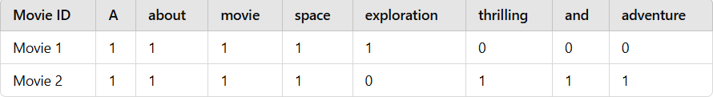

Explanation:
- Movie 1: Contains the words "A", "about", "movie", "space", and "exploration" in its description. The values "1" indicate that each of these words appears at least once in the movie's text.
- Movie 2: Contains the same words as Movie 1, but additionally includes
"thrilling", "and", and "adventure". The value "1" indicates the presence of these words in Movie 2's description.
This matrix helps to represent the textual data as numerical vectors, which can then be used to calculate similarities between movies based on their word usage and features. The CountVectorizer essentially creates a sparse matrix of term frequencies, enabling the system to compare movies based on common keywords.

Cosine Similarity
Cosine similarity is a way to measure how alike two vectors are, regardless of their size. It’s often used in text analysis and NLP to compare documents, and it can also be used in movie recommendation systems.

Formula for Cosine Similarity
The mathematical formula for cosine similarity between two vectors A and B is given by:

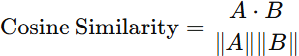

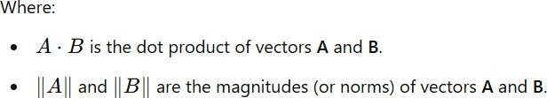

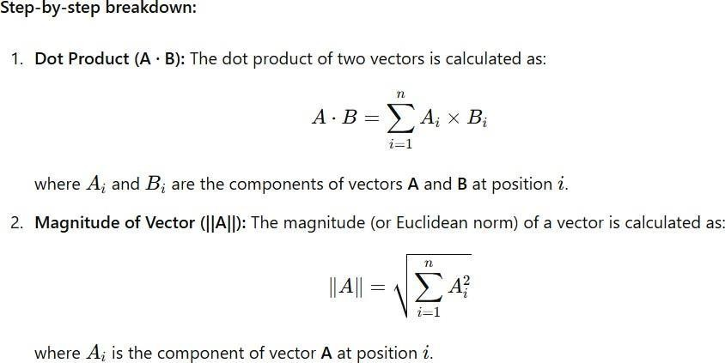

- Cosine Similarity Value: After calculating the dot product and the magnitudes of the vectors, the cosine similarity value is found by dividing the dot product by the product of the magnitudes of A and B. This results in a value between -1 and 1:
  - 1 indicates that the vectors are identical (i.e., the movies are very similar).
  - 0 indicates that the vectors are orthogonal, meaning no similarity (i.e., the movies have no common features).
  - -1 indicates that the vectors are diametrically opposed (i.e., the movies are completely dissimilar).

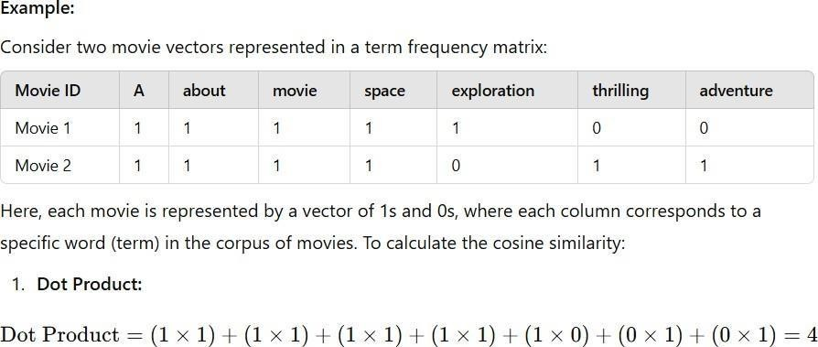

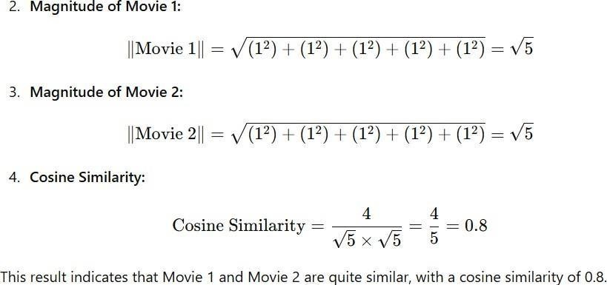

Use of Cosine Similarity in Movie Recommendation:

For movie recommendations, cosine similarity compares the vector of a chosen movie with vectors of other movies in the dataset. Movies with the highest similarity scores are recommended to the user, making sure the suggestions share similar features like genres, keywords, or other attributes.

Implementation
In this section, we delve into the practical aspects of implementing the movie recommendation system using the TMDB 5000 dataset and a secondary dataset containing cast and crew information. The system is built using Python, leveraging popular libraries like Pandas, NumPy, and Sklearn to preprocess data and calculate similarities.

Tools and Libraries Used
The following tools and libraries are essential for the implementation:
- Python – The primary programming language used.
- Pandas – For data manipulation and preprocessing.
- NumPy – For numerical operations.
- Sklearn (Scikit-learn) – To use CountVectorizer and calculate Cosine Similarity

Code Explanation
Here’s a breakdown of the critical parts of the code that contribute to building the recommendation system:
Data Preprocessing

- Remove unnecessary columns like homepage, status, and others.
- Merge datasets based on movie_id to include cast and crew information.

Feature Engineering

- Combine relevant features (genres, keywords, cast, crew) into a unified "tags" column.
- Use NLP techniques like CountVectorizer to convert textual data into numerical form

Similarity Calculation

- Use the CountVectorizer to create the Bag-of-Words model.
- Compute the cosine similarity matrix to determine the pairwise similarity between movie vectors.

Creation of Movie Vectors and Similarity Calculation
The movie vectors are generated using the Bag-of-Words model, and the cosine similarity matrix is calculated as follows:

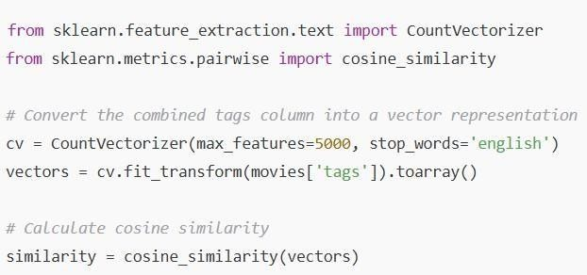

Figure No. :- 1

Evaluation and Results

Evaluation in the context of Machine Learning is the process of assessing how well a trained model performs on a given dataset, particularly unseen or test data. It involves using quantitative metrics to measure the model’s ability to make accurate predictions and generalize to new data. Evaluation ensures that the model is not overfitting or underfitting and gives an understanding of how well it works in real-world applications. Common evaluation metrics include accuracy, precision, recall, F1-score, and metrics like RMSE for regression tasks.

Evaluation
In this project, traditional recommendation system metrics like Precision, Recall, or F1-score were not employed due to the focus on content-based filtering. Instead, the evaluation is based on:
- Qualitative Assessment: Analyzing the quality of movie recommendations through manual inspection.
- User Feedback: Observing how well the system meets user expectations by
suggesting relevant movies.

Performance Analysis
The model demonstrated effective recommendations by leveraging the content-based approach:
- High Similarity for Relevant Movies: Movies sharing keywords, genres, and cast were highly ranked.
- Efficient Vectorization: The use of the Bag-of-Words model and
CountVectorizer ensured efficient feature extraction, enhancing recommendation quality.

Sample Recommendations and Results

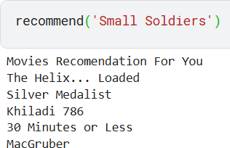
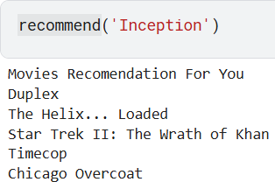
Figure No. :- 2 Figure No. :- 3

Frontend of the Project
The frontend of the movie recommendation system is developed using Streamlit, a Python library that enables easy creation of web applications for data science projects. It serves as the interface through which the user interacts with the backend of the system to get movie recommendations. The frontend provides a simple interface where users can input a movie they have already seen and receive a list of recommended movies based on similarity.

Streamlit Interface Setup
Streamlit makes the implementation of the frontend intuitive and quick. First, the necessary libraries such as Streamlit, pickle, and pandas are imported. The movies_dict and similarity matrices, which are precomputed and stored in pickle files, are loaded to be used by the recommendation system.
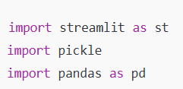

Figure No. :- 4

User Input Handling (Movie Selection)
The user is prompted to enter the title of a movie they have already seen using the selectbox widget. This allows the user to pick from a dropdown list of available movie titles extracted from the dataset. Once the user selects a movie and clicks the "Recommend" button, the recommendation function is triggered.

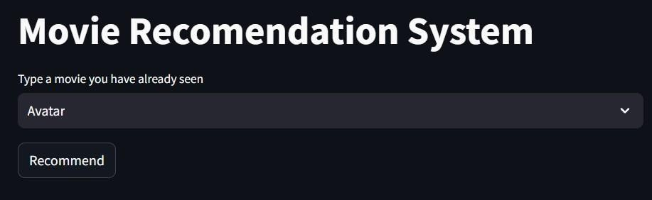

Figure No. :- 5
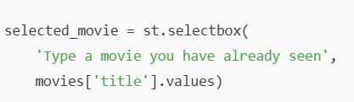

Displaying Recommendations
When the user clicks the "Recommend" button, the system processes the movie title and fetches the top 5 recommended movies using the similarity matrix. The recommended movie titles are then displayed on the screen using st.write(), which outputs text to the app. Each movie title is shown as a new line of text in the Streamlit app.
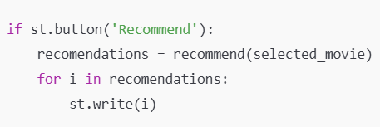
Figure No. :- .6

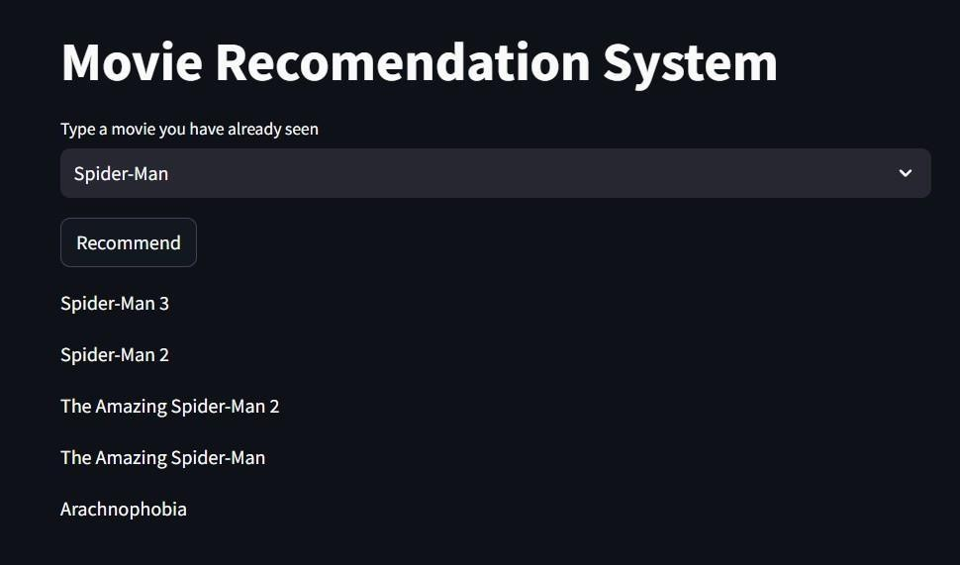

Figure No. :- 7
This simple interface allows users to quickly interact with the recommendation system and see results based on their movie preferences. The frontend effectively bridges the user’s input with the machine learning backend to provide relevant movie suggestions.

Discussion and Analysis
The Discussion and Analysis section provides a deeper insight into the results obtained from the project, analyzing both the strengths and limitations of the movie recommendation system. This section also discusses the challenges faced during the implementation phase and the valuable lessons learned.

Strengths and Limitations of the Model
The recommendation model developed using cosine similarity and the Bag of Words approach exhibits several strengths, such as its simplicity, ease of implementation, and the ability to provide personalized movie recommendations based on user input. By leveraging the genres, cast, crew, and keywords, the model can recommend movies that are highly similar to the one chosen by the user. It does not require any complex or

computationally expensive methods, which makes it efficient for a basic recommendation system.
However, the model also has limitations. First, it relies purely on textual data (such as movie descriptions and metadata) without incorporating user ratings or reviews, which are crucial for personalized recommendations. Second, the model struggles to handle large datasets because the term frequency matrix grows big, and calculating cosine similarity becomes more expensive. Additionally, it may recommend movies that are overly similar in terms of metadata but lack deeper contextual or subjective relevance, such as genre preferences or user tastes.

Challenges Faced During Implementation
Building this recommendation system had some challenges. One major challenge was preparing the data by cleaning and organizing it for analysis. This included dealing with missing values, removing unnecessary columns, and making sure the data was consistent. Also, choosing the right features like genres, keywords, and cast was important to help the system suggest the most relevant movies for users.
Another challenge was calculating cosine similarity, which becomes slow as the dataset grows larger. For bigger datasets, advanced methods like matrix factorization or deep learning are needed to improve speed. Also, creating an easy-to-use interface with Streamlit was challenging, especially in handling real- time user input and keeping the backend and frontend working smoothly together.

Insights Gained from the Project
Throughout this project, several key insights were gained:
- Data Quality is Crucial: Ensuring high-quality data is foundational to building an effective recommendation system. Preprocessing and cleaning the data appropriately can significantly improve the quality of the recommendations.
- Simplicity vs. Complexity: While simple models like the one used in this project are easy to implement, they often lack the ability to capture more complex

relationships within the data. Incorporating user preferences, ratings, and feedback can improve the model's accuracy.
- Scalability Issues: As datasets grow, traditional similarity-based methods (like
cosine similarity) may not scale efficiently. More advanced methods, such as collaborative filtering or hybrid models, are often necessary to handle large datasets and generate better recommendations.
- User Interaction: The importance of user interaction was highlighted, as the Streamlit interface provided a practical and accessible way to implement the system, offering users a seamless experience in obtaining movie recommendations based on their input.

Future Work
The Future Work section discusses potential improvements and extensions for the movie recommendation system, including advanced techniques, scalability considerations, and additional features that could enhance the overall system's performance and user experience.

Potential Improvements
One key area for improvement is incorporating user ratings and feedback into the recommendation model. Currently, the model only relies on metadata such as genres, keywords, and cast, which may not fully capture individual preferences. By integrating user-specific data, such as movie ratings, reviews, or viewing history, a collaborative filtering approach could be implemented. This would enable the system to provide more personalized recommendations based on user behavior and preferences.
Additionally, the current system uses a basic Bag of Words approach, which could be replaced with more advanced techniques like TF-IDF (Term Frequency-Inverse Document Frequency) or Word2Vec. These methods would improve the accuracy of the recommendations by considering the importance of terms in the context of the entire dataset rather than just their occurrence. Implementing deep learning models, such as Recurrent Neural Networks (RNN) or Autoencoders, could also enhance the quality of recommendations by better capturing complex patterns in the data.

Scalability and Extensions
As the dataset grows, the current method of calculating cosine similarity can become computationally expensive. To address this, techniques like approximate nearest

neighbors (ANN), which allow for faster similarity searches, could be used. Matrix factorization techniques like Singular Value Decomposition (SVD) can help lower computational costs and make the system easier to scale
Furthermore, integrating additional sources of data, such as social media trends, user-generated content, and movie trailers, could enrich the recommendation process. For example, adding sentiment analysis from social media could offer useful information about user preferences and improve the quality of recommendations.

Enhanced User Interface
To make the recommendation system more user-friendly, the Streamlit frontend could be enhanced with features such as user authentication, personalized dashboards, and improved visualizations. Implementing a search functionality that allows users to filter movies based on additional criteria like year, ratings, or genres could make the system more versatile. A feedback mechanism could also be introduced to allow users to rate the recommendations, providing valuable data to improve the system over time.

Multi-Modal Recommendations
Another future direction is to build a multi-modal recommendation system that combines movie details with extra data like trailers, reviews, and user ratings. This would create a more complete system using different data types for better suggestions. For example, a deep learning model that handles both text and images could give more accurate recommendations by analyzing movie content and visuals like posters or trailers.

Real-Time Recommendations
To make the recommendation system more dynamic, the implementation could be extended to offer real-time recommendations. By tracking user behavior (such as movies watched or searched for) and continuously updating recommendations based on the latest activity, the system could provide up-to-date suggestions without requiring users to re-enter their preferences.

Conclusion
In this project, we built a movie recommendation system using content-based filtering. Using the TMDB 5000 Movies dataset, we focused on movie details like genres, keywords, and cast to create a model that finds similar movies. Techniques such as CountVectorizer and Bag of Words were used to process the text data.

The recommendation system worked well in suggesting relevant movies, but it could be improved by adding user ratings, collaborative filtering, or advanced methods like deep learning. Using more advanced text methods like TF-IDF or Word2Vec could also make recommendations better.
This project showed that it’s possible to create a basic movie recommender and demonstrated how machine learning and NLP can be used in practical applications. Future improvements will include using a larger dataset and making the model better at handling more complex recommendation tasks.

Summary of Findings
This project developed a content-based movie recommendation system using the TMDB 5000 Movies dataset. It used movie details like genres, keywords, and cast to find similarities between movies. CountVectorizer and the Bag of Words model were applied to turn the text data into a matrix of word counts, which helped in making recommendations. The system was able to suggest movies based on how similar they were to a selected movie. This approach showed how natural language processing (NLP) can be used to create a basic recommendation engine.

Key Takeaways
- Data Preprocessing and Feature Engineering: Preprocessing the data and selecting relevant features such as movie genres, keywords, and cast is crucial for creating an effective recommendation system.
- Content-Based Filtering: Content-based filtering approaches, particularly using
Bag of Words and CountVectorizer, are effective for generating recommendations when user interaction data (such as ratings) is not available.

- Improvement Potential: The current system could be enhanced by incorporating user ratings, exploring collaborative filtering techniques, or using advanced methods like TF-IDF for text representation.
- Real-World Application: The project highlights the applicability of machine learning and NLP in solving real-world problems like movie recommendation, with potential for scalability and refinement.

References
  - Python Programming Language – Core language used for data processing and model implementation.
https://docs.python.org/3/
  - Pandas Library – Used for data manipulation and analysis. https://pandas.pydata.org/docs/
  - NumPy Library – Utilized for numerical computations and array handling.
https://numpy.org/doc/
  - Scikit-learn Library – Used for CountVectorizer and cosine similarity calculations.
https://scikit-learn.org/dev/versions.html
  - Streamlit Framework – Used to build the frontend of the recommendation system.
https://docs.streamlit.io/
  - Kaggle – Source of the TMDB 5000 Movies Dataset and credits dataset. https://www.kaggle.com/datasets/tmdb/tmdb-movie-metadata
  - Hands-On Machine Learning with Scikit-Learn, Keras, and TensorFlow by
Aurelien Geron – Reference book for machine learning concepts.

Appendices
The appendices section provides supplementary materials that support the content of the project report, including additional code snippets or any relevant resources that enhance the understanding of the project.

12.2 Full Code
import numpy as np # importing numpy library
import pandas as pd # data processing, CSV file I/O (e.g. pd.read_csv) movies =
pd.read_csv('/kaggle/input/tmdb-movie-metadata/tmdb_5000_movies.csv')

credits =
pd.read_csv('/kaggle/input/tmdb-movie-metadata/tmdb_5000_credits.csv') movies.shape
credits.head()
movies = movies.merge(credits,on='title') movies.head()
# budget
# homepage # id
# original_language # original_title
# popularity
# production_comapny # production_countries # release-date(not sure)
movies = movies[['movie_id','title','overview','genres','keywords','cast','crew']]
movies.head() import ast
def convert(text): L = []
for i in ast.literal_eval(text): L.append(i['name'])
return L movies.dropna(inplace=True)

movies['genres'] = movies['genres'].apply(convert) movies.head()
movies['keywords'] = movies['keywords'].apply(convert)
movies.head() import ast
ast.literal_eval('[{"id": 28, "name": "Action"}, {"id": 12, "name": "Adventure"},
{"id": 14, "name": "Fantasy"}, {"id": 878, "name": "Science Fiction"}]') def convert3(text):
L = []
counter = 0
for i in ast.literal_eval(text): if counter < 3:
L.append(i['name']) counter+=1
return L
movies['cast'] = movies['cast'].apply(convert) movies.head()
movies['cast'] = movies['cast'].apply(lambda x:x[0:3]) def fetch_director(text):
L = []
for i in ast.literal_eval(text): if i['job'] == 'Director':
L.append(i['name']) return L
movies['crew'] = movies['crew'].apply(fetch_director)
#movies['overview'] = movies['overview'].apply(lambda x:x.split()) movies.sample(5)
def collapse(L): L1 = []
for i in L: L1.append(i.replace(" ",""))
return L1

movies['cast'] = movies['cast'].apply(collapse) movies['crew'] = movies['crew'].apply(collapse) movies['genres'] = movies['genres'].apply(collapse) movies['keywords'] = movies['keywords'].apply(collapse) movies.head()
movies['overview'] = movies['overview'].apply(lambda x:x.split()) movies['tags'] = movies['overview'] + movies['genres'] + movies['keywords'] + movies['cast'] + movies['crew']
new = movies.drop(columns=['overview','genres','keywords','cast','crew']) #new.head()
new['tags'] = new['tags'].apply(lambda x: " ".join(x))
new.head()
from sklearn.feature_extraction.text import CountVectorizer
cv = CountVectorizer(max_features=5000,stop_words='english')

vector = cv.fit_transform(new['tags']).toarray()

vector.shape
from sklearn.metrics.pairwise import cosine_similarity similarity = cosine_similarity(vector)
similarity
new[new['title'] == 'The Lego Movie'].index[0] def recommend(movie):
index = new[new['title'] == movie].index[0]
distances = sorted(list(enumerate(similarity[index])),reverse=True,key = lambda x: x[1])
for i in distances[1:6]: print(new.iloc[i[0]].title)
recommend('Gandhi')

Gandhi, My Father #output
The Wind That Shakes the Barley #output
A Passage to India #output

Guiana 1838 #output
Ramanujan #output

import pickle pickle.dump(new,open('movie_list.pkl','wb')) pickle.dump(similarity,open('similarity.pkl','wb'))
Frontend
# Import necessary libraries
import streamlit as st # Streamlit for creating the web app
import pickle # To load serialized data (movies and similarity matrix) import pandas as pd # Pandas for data manipulation

# Function to recommend movies based on the input movie def recommend(movie):
# Find the index of the selected movie
movie_index = movies[movies['title'] == movie].index[0]

# Retrieve the similarity scores for the selected movie distances = similarity[movie_index]

# Sort movies by similarity score in descending order and pick the top 5 movie_list = sorted(list(enumerate(distances)), reverse=True, key=lambda x:
x[1])[1:6]

recommended_movies = [] for i in movie_list:
# Append the title of the recommended movies recommended_movies.append(movies.iloc[i[0]].title)
return recommended_movies

# Load the movie dictionary and similarity matrix using Pickle movies_dict = pickle.load(open('movies_dict.pkl', 'rb')) similarity = pickle.load(open('similarity.pkl', 'rb'))

# Convert the movie dictionary to a DataFrame for easier access movies = pd.DataFrame(movies_dict)

# Streamlit app title
st.title("Movie Recommendation System")

# Dropdown for user to select a movie selected_movie = st.selectbox(
'Type a movie you have already seen', # Dropdown label movies['title'].values # List of movie titles for selection
)

# Button to trigger the recommendation process if st.button('Recommend'):
# Get recommendations for the selected movie recommendations = recommend(selected_movie)

# Display the recommended movies for i in recommendations:
st.write(i)

12 Glossary/Abbreviations

NLP (Natural Language Processing):
A field of AI that focuses on the interaction between computers and

human language, enabling machines to process and analyze large amounts of natural language data.

Bag of Words (BoW):
A text representation technique that converts text into a collection of words and their frequency, ignoring grammar and word order.

CountVectorizer:
A tool used to convert a collection of text documents into a matrix of token counts, typically used in NLP tasks.

Cosine Similarity:
A metric that measures the cosine of the angle between two vectors, used to determine how similar two items are in a multidimensional space.

Pickle:
A Python library used to serialize and deserialize Python objects, allowing data to be saved and loaded efficiently.

Pandas:
A Python library used for data manipulation and analysis, providing data structures like DataFrames.

Streamlit:
An open-source Python library used to create interactive web applications for machine learning and data science projects.

Dataset:
A collection of data used to train, test, or evaluate a machine learning model.

TMDB (The Movie Database):
A popular database for movies and TV shows that provides structured data used in this project.

Similarity Matrix:
A matrix that contains similarity scores between all pairs of items (movies in this case) used to find related items.

Movie ID:
A unique identifier assigned to each movie in the dataset.

Python:
A high-level programming language used extensively in machine learning and data analysis projects

